

Elementary
Lunch Menu
September 2023

MONDAY | TUESDAY | WEDNESDAY | THURSDAY | FRIDAY
 |  |  |  | 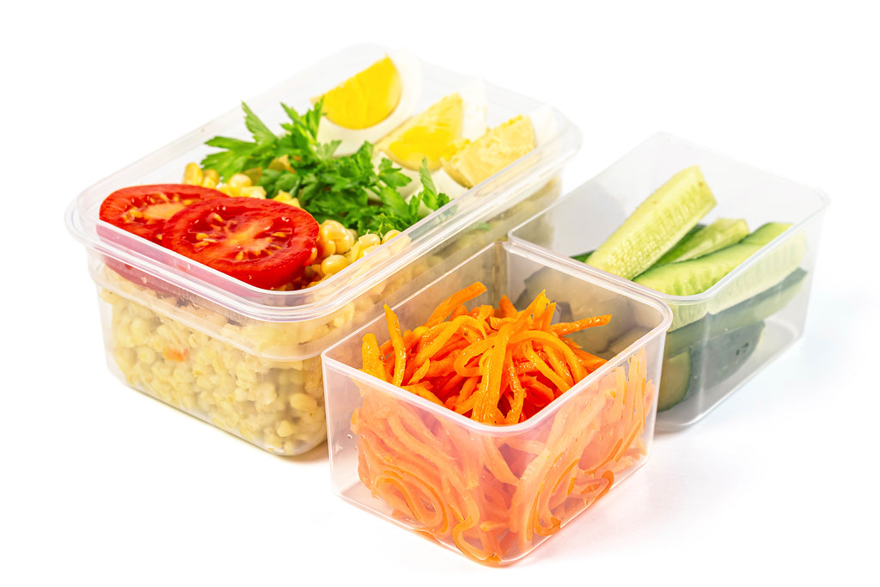 | More Info…  Offered Daily:  Yogurt Munchable-  Yogurt, Bagel or Whole Grain Crackers and String Cheese/(V)  Peanut butter cups may be substituted for yogurt/string cheese  *Peanut Butter Munchable-Peanut Butter & Jelly, String Cheese & Goldfish Crackers/(V)  Tossed Salad w/ Egg/(V) or Turkey & Cheese  Sandwich Menu  Monday &Wednesday  Italian Sub on  WG Roll  Tues, Thurs, Fri  Sliced Turkey w/ Cheese on  WG Roll  Cheese Hoagie/(V)  Assorted Milk:  1% White  Skim  Fat Free Chocolate  Fat Free Strawberry  Choose one fruit from the variety offered daily. Choices will be posted  on the service line.
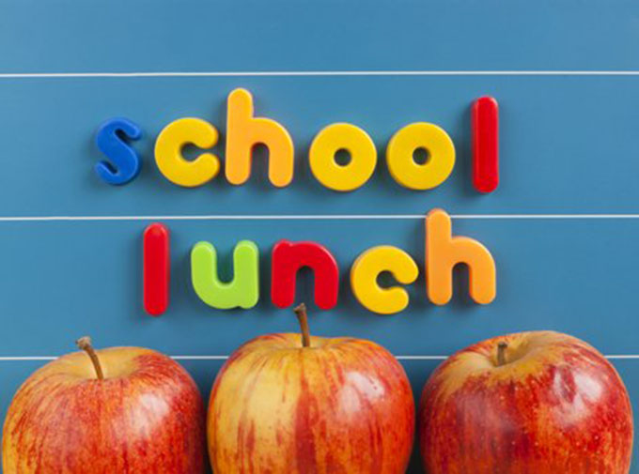 |  | 6  Cheeseburger  Baked French Fries  Baked Bean Supreme  Chilled Peaches  Assorted Fresh Fruits/Vegetables  Milk | 7  Cheese Cavatappi  WG Biscuit  Chilled Applesauce  Italian Green Beans  Assorted Fresh Fruits/Vegetables | 8  Domino’s Day  Romaine Boats w/ Croutons  Pepper Strips  Chilled Peaches  Fresh Fruits &Veggies
11  Tony’s Egg &  Cheese Bagel  Hashbrown Rounds/3  Broccoli Salad  Baked Apples  Chilled OJ  Milk | 12  Taco in a Bag w/ Cheese Sauce &  Taco Meat  Brown Rice & Corn  Chilled Cucumber  Chilled Pineapple | 13  Hot Ham & Cheese on a Pretzel Bun  Sweet Potato Fries  Roasted Chickpeas  Chilled  Mandarin Oranges  Fresh Fruits & Veggies | 14  GO EAGLES  Hot Dog  Seasoned Fries  Baked Bean Supreme  Smart Food Popcorn  Wear your Green! | 15  Pizza Party  Cran-Apple  Spinach Salad  Sliced Pepper Cups  Fresh Fruits & Veggies
18  Grilled Cheese  Warm Tomato Soup  Seasoned Peas  Chilled Pears  Fresh Fruits & Veggies | 19  Taco in a Bag w/ Cheese Sauce &  Taco Meat  Brown Rice & Corn  Chilled Cucumber  Chilled Pineapple | 20  Chicken Nuggets/5  WG Biscuit w/ Margarine  Baked Sweet Potatoes & Apples  Chickpea Salad  Chilled Blueberries | 21  Pancakes/2  Turkey Sausage Links/2  Hashbrown Rounds/3  Chilled OJ  Fresh Fruits & Veggies | 22  Pizza Party  Romaine Boats w/ Croutons  Pepper Strips  Chilled Peaches  Fresh Fruits &Veggies
25  Egg & Cheese on  WG Croissant  Hashbrown Rounds/3  Baked Apples  Fresh Fruits & Veggies | 26  Taco in a Bag w/ Cheese Sauce &  Taco Meat  Brown Rice & Corn  Black Bean & Corn Salad  Chilled Pineapple  - | 27  Spaghetti & Meatballs/2  Garlic Bread  Romaine Boats  Italian Green Beans Fresh Fruits & Veggies | 28  Chicken & Waffle Sticks w/ Syrup  Candied Carrots  Chickpea Salad  Chilled Apricots  Fresh Fruits & Veggies | 29  Pizza Party  Cran-Apple  Spinach Salad  Sliced Pepper Cups  Fresh Fruits & Veggies

Washington Township Pre-School Lunch Menu
Meal Applications Now Available Online!  www.Payschoolscentral.com  WT Food Service Department 856-582-4010 | Menus are subject to change without notice.  *IW=Individually Wrapped

